**Trabajo Práctico 9 - Sistemas Operativos**

**Integrantes:**

* Borgogno, Francisco
* Cañas, Felipe
* Lucero Ruiz, Maximo
* Quesada, Santiago

**Profesor:** Funes, Gustavo

**1.**

| **mkdir ./dir1 chmod 700 ./dir1  touch ./dir1/file1 chmod 666 ./dir1/file1  touch ./dir1/file2 chmod 644 ./dir1/file2  mkdir ./dir2 chmod 750 ./dir2  touch ./dir2/file1 chmod 660 ./dir2/file1  touch ./dir2/file2 chmod 640 ./dir2/file2** |
| --- |

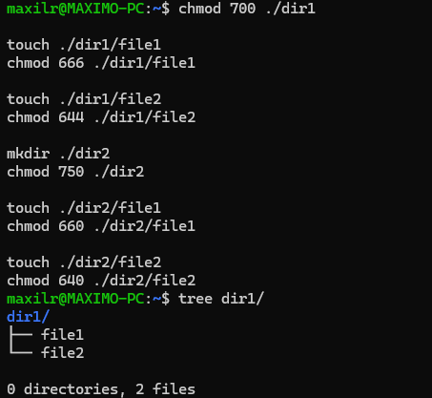

**2.**

| **sudo su** |
| --- |



**3.**

| **mkdir ./test chmod 775 ./test** |
| --- |



**4.**

| **chown jd:students ./test** |
| --- |



**5.**

| **mkdir ./test2 chmod 1777 ./test2** |
| --- |





**6.**

| **sudo useradd -c "Usuario de prueba" -G students alfas** |
| --- |



**7.**

| **getent passwd alfa** |
| --- |



**8.**

| **sudo usermod -L alfa** |
| --- |

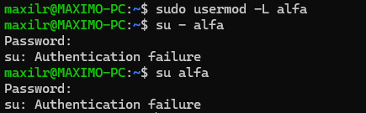

**9.**

| **sudo usermod -U alfa** |
| --- |

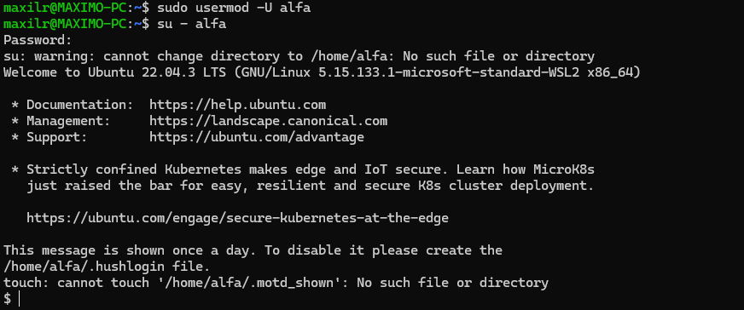

**10.**

| **sudo userdel alfa** |
| --- |





**11.**

| **echo "Bzrp Music Sessions, Vol. 36, Bizarrap y L-Gante\nAdemás de Mí, Rusherking, Tiago PZK, KHEA, Duki, María Becerra\nMamichula, Trueno y Nicki Nicole\nElla Es una G, KHEA\nColocao, Nicki Nicole" > music.txt sudo chown jd:students music.txt** |
| --- |

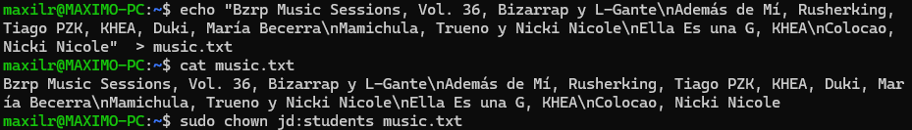

**12.**

| **mkdir work umask 022** |
| --- |



**13.**

| **mkdir dira dirb dirc dird** |
| --- |



| **ls -l** |
| --- |

